AP CSP Python with Robots  Functions, Parameters and Variables Activity Guide |  | Name:
Introduction
During this assignment, you will discuss when a function needs parameters, local variables and global variables.
Warm-Up Reflect on the functions you have defined and used since Mission 3.
What is a function?
How do you define and call a function?
When do you use a function – what are its purposes?
Parameters and Local Variables Problems: List each variable. Indicate if it is a parameter or local variable. How is it used in the code? Insert more rows for each problem, as needed.
#1  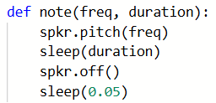
  Variable Name | Type | How it is used
  freq | parameter | Argument in function call
#2  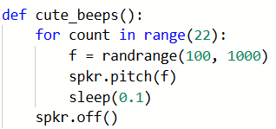
  Variable Name | Type | How it is used
#3  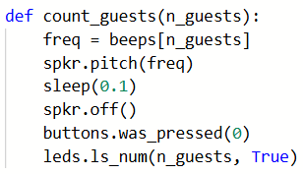
  Variable Name | Type | How it is used
#4  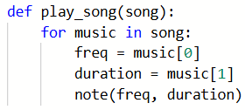
  Variable Name | Type | How it is used
#5  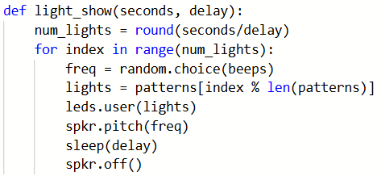
  Variable Name | Type | How it is used
Parameters, Local Variables and Global Variables Problems: List each variable. Indicate if it is a parameter, local variable or global variable. Insert more rows for each problem, as needed.
#6  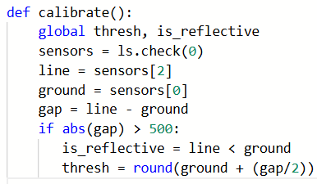
  Variable Name | Type | How it is used
#7  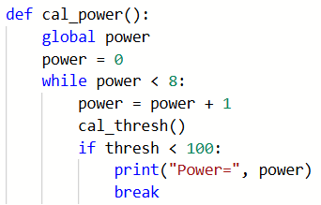
  Variable Name | Type | How it is used
#8  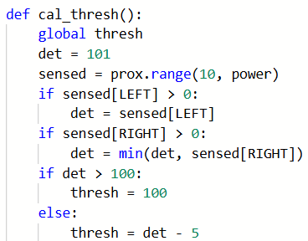
  Variable Name | Type | How it is used
#9  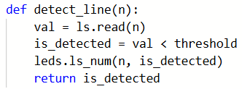
  Variable Name | Type | How it is used
#10  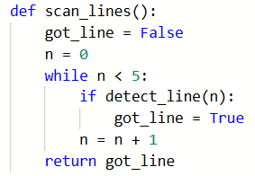
  Variable Name | Type | How it is used
Wrap-Up
Give two benefits of using functions? (How do they manage complexity)?
What is a parameter, and what are some reasons to use a parameter in a function?
What are local variables, and when would you use them?
What are global variables, and when would you use them?
Submit this assignment to the teacher.

